**Tweets collected from Twitter on @easyjet keyword**

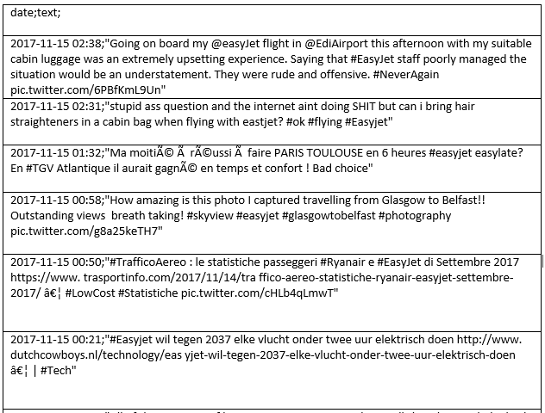

**Outputs from preprocessingTweets.py**

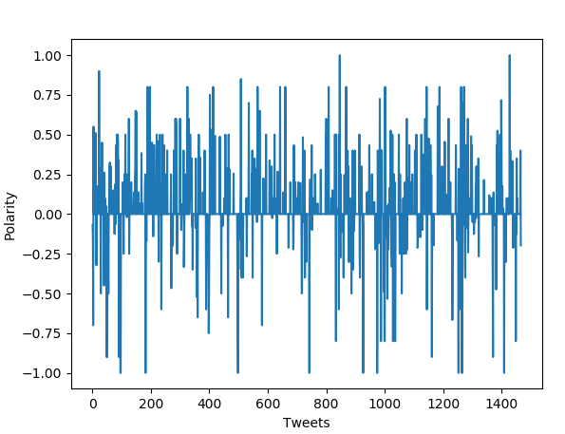

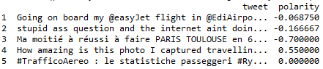

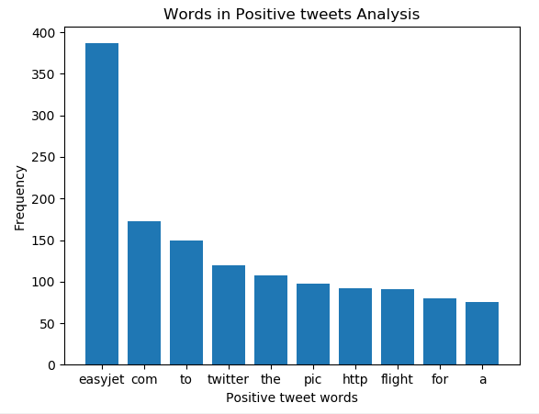

**Output from wordCloud.py**

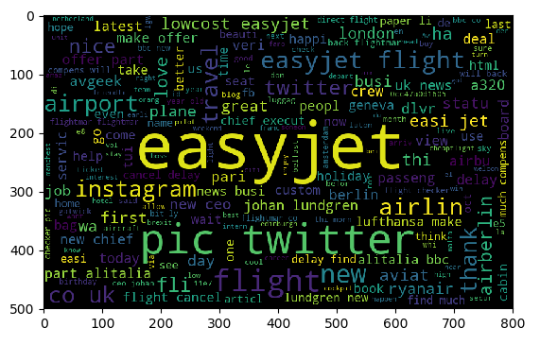

**Output from hashTagAnalysis.py**

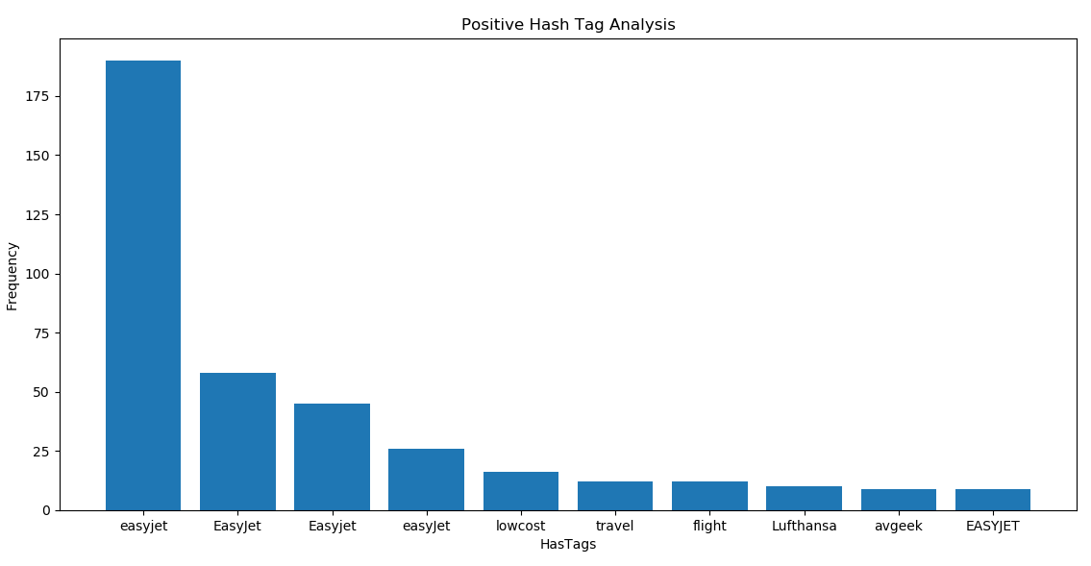

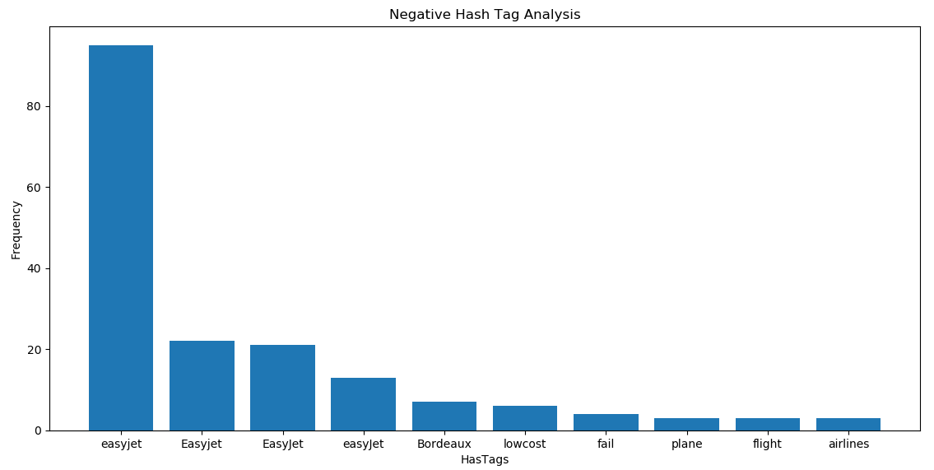

**Output from bigramAnalysisAndNetwork.py**

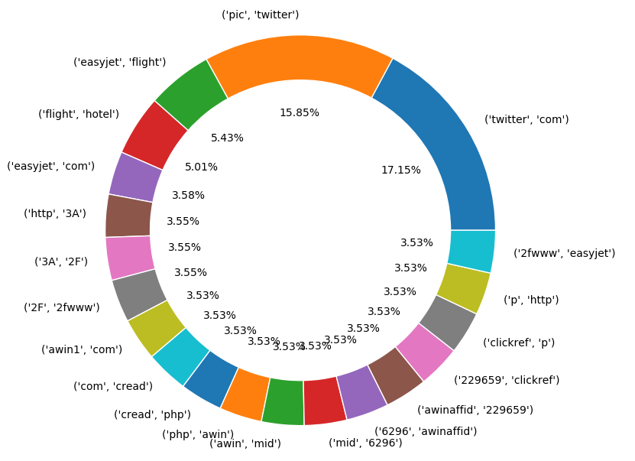

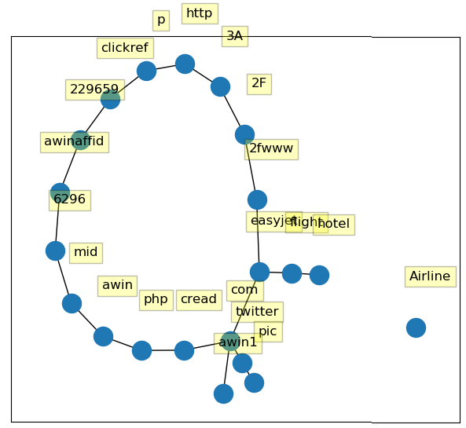

**Output from bagOfWordPrediction.py**



**Output from tf_idfFeaturesPrediction.py**

